Mawddach Pickleball Club

The Club’s Goal
To grow pickleball locally through social play opportunities, working towards offering matchplay and a local ladder league for interested players.

The Beginnings
In search of a venue, we approached Dolgellau Leisure Centre and they have been immensely supportive. They offered us the whole sports hall on Tuesday afternoons as a Fit for Life session, fixing the cost at £3 per player, enabling us to grow as a club without needing to worry about numbers, court bookings and costs each week.
It was important for us as a club to offer an evening session as well as a daytime session. Thursday evenings were available, but MPC would have to meet the costs of hiring the courts. We had three weeks of Tuesday play to get off the ground with numbers and be viable for running Thursday sessions.
This week is our 7th Tuesday and 4th Thursday session so we are still very young. Our focus has been on recruiting players, welcoming them to the club and helping them get playing and enjoying pickleball. We have tried to cater for players of different sporting backgrounds and abilities.

Session Format
We weren’t sure of the best format for sessions. Obviously, all first time players need an introduction to the game, but for the format around that we have been trying about 20-30 minutes warm up and drills followed by gameplay.

Introduction to Pickleball
Introduction to pickleball for first timers covers: getting a feel for the paddle and the ball, dinking, the ‘kitchen’ / Non Volley Zone, the serve (simplified), the return of serve, the double bounce rule, court positions and scoring. We feel that is enough (and plenty!) to get playing.

Warm Up and Drills
We feel the warm up is essential to help ensure bodies are warmed up and risk of injury is reduced. As players ourselves in clubs further afield we recognise the benefit of drills. They offer an opportunity to focus on particular skills through repetition and experimentation that is not possible in gameplay and contribute to developing a player’s strategic gameplay. Our activities are planned to be a warm up initially, and then to be interesting, varied, useful and progressive. They also need to be appropriate to the mixed ability levels in the group. In terms of planning, we have to remember not everyone attends every session. The skills we have covered so far include: dinking, speed/reactions at the net, deep serves, serve direction, return of serve and down the line shots.

Gameplay
We have trialled various gameplay options:
- Printed round robins catering for differing numbers of players. These have the advantage of being able to merge as many courts as desired or separate into smaller units – basically anything from everyone in one large round robin to one round robin per court. They also accommodate doubles practice with fixed partners which is useful prior to some matchplay situations. They also allow either for timed play or simply playing each game through to completion.
- Using an app which organises players randomly across the available courts and works based on fixed timings (typically 8-10 minutes per game).
- Split and rotate: All courts stop play at the same time (typically after 8-10 minutes) and winners stay on their court but split and losers move along one court and split.
- Matchplay

What Next?
We are starting to get feedback, but it’s contradictory so we need more!
What are you looking for? What are you enjoying? What could be better? What don’t you like?
Some people want more coaching, some want less drilling but there’s an obvious overlap here.
Would you be interested in regular matchplay? Whilst our numbers are relatively low, this would probably be groups of 5 or 6 players playing 8 or 10 games in various combinations of partners and opponents. As our numbers grow, the outcome of these games can be fed into an algorithm that ranks players which then enables players to play within well-matched groups. Maybe you’d be interested in matchplay say on the last Thursday of each month?

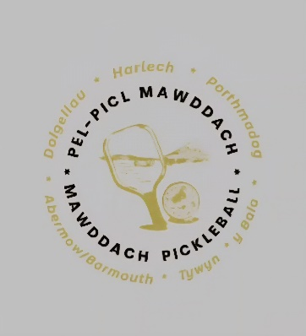
Please remember we are not coaches, just pickleball addicts.

